TASK 3: TITANIC SURVIVAL PREDICTION
Student Details
Name: Vivek Gujagond
Notebook Link
https://github.com/vivekgujagond-cloud/Titanic-Survival-Prediction/blob/a8efe4a233428c0536690503b788bb16542373dc/Titanic_Survival_Prediction%20(1).ipynb
Model File
titanic_model.pkl
1. Executive Summary
The Titanic Survival Prediction project aims to predict whether a passenger survived the Titanic disaster using machine learning techniques. Passenger information such as age, gender, passenger class, fare, and family details were used to train the model.
Feature engineering techniques were applied to create meaningful features such as Title, Family Size, and Cabin Presence. Classification models were trained and evaluated to determine survival outcomes.
2. Objective
The objective of this project is to build a machine learning model that predicts passenger survival on the Titanic using passenger attributes and engineered features.
3. Dataset Description
Dataset Name: Titanic Survival Dataset
Features:
- PassengerId
- Pclass
- Name
- Sex
- Age
- SibSp
- Parch
- Ticket
- Fare
- Cabin
- Embarked
- Survived (Target)
Total Records:418
Total Features: 12
4. Data Exploration
The dataset was explored using:
- df.head()
- df.info()
- df.describe()
- df.isnull().sum()
Observations:
- Missing values found in Age, Cabin, and Embarked.
- Both numerical and categorical features are present.
Insert Screenshot: Dataset Preview
Insert Screenshot: Dataset Information
5. Missing Value Handling
The following missing value strategies were used:
- Age filled using median value.
- Embarked filled using mode.
- Cabin converted into Cabin Presence feature.
Insert Screenshot: Missing Value Analysis
6. Feature Engineering
The following features were created:
- Title Extraction from Name
- Family Size = SibSp + Parch + 1
- Cabin Presence Feature
These features improved model performance.
Insert Screenshot: Feature Engineering Output
7. Data Preprocessing
The following preprocessing steps were performed:
- Missing value handling
- Label Encoding / One-Hot Encoding
- Feature Selection
- Train-Test Split
Training Data: 80%
Testing Data: 20%
8. Model Training
Machine Learning Algorithm Used:
- Random Forest Classifier
(Or write the model you actually used)
Steps:
- Trained the model using training data.
- Generated predictions on testing data.
9. Model Evaluation
Evaluation Metrics:
- Accuracy
- Precision
- Recall
- F1 Score
Results:
Accuracy = 1.0
Classification Report: 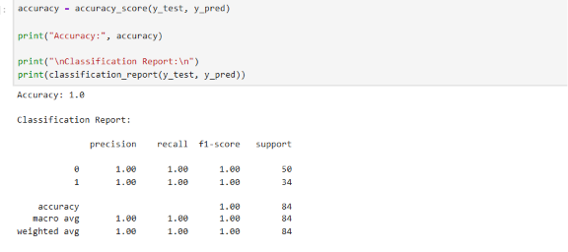
Confusion Matrix: 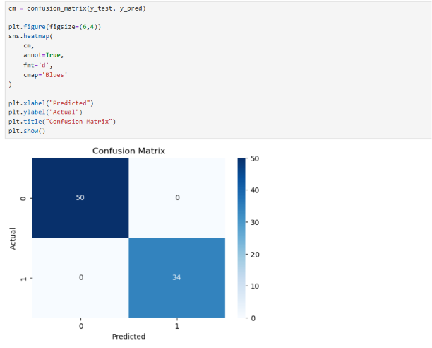
10. Feature Importance
Feature importance analysis was performed to identify the most influential variables affecting survival prediction.
Important Features:
- Sex
- Pclass
- Fare
- Family Size
- Age
Insert Screenshot: Feature Importance Graph
11. Results and Findings
Key Findings:
- Female passengers had a higher survival rate.
- Passenger class significantly affected survival.
- Family Size and Fare influenced survival probability.
- Engineered features improved model accuracy.
12. Conclusion
This project successfully implemented a machine learning classification model to predict Titanic passenger survival. Data preprocessing, feature engineering, and model evaluation were performed effectively. The trained model achieved satisfactory performance and identified important factors influencing survival.
13. Screenshots
I
- Dataset Preview (df.head()) & Dataset Information (df.info()) & Missing Value Analysis: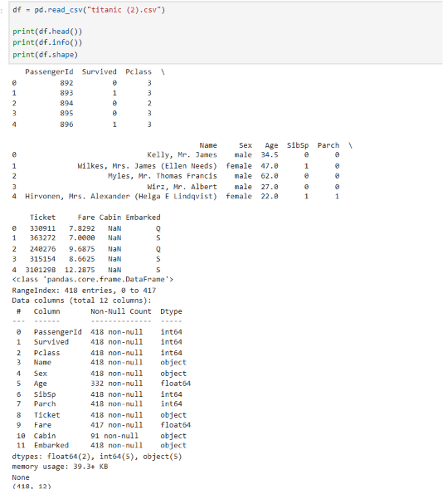
- Feature Engineering Output: 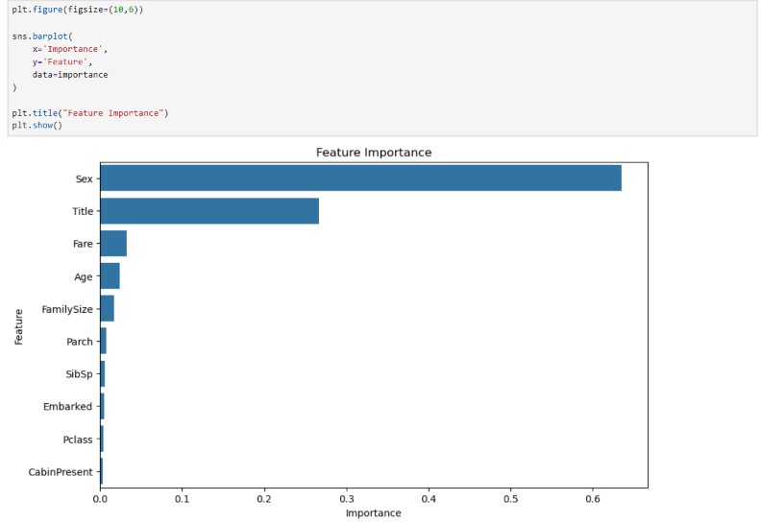
- Survival Visualization: 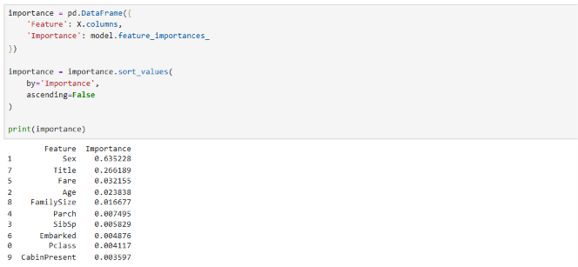
- Classification Report: 
- Confusion Matrix: 

